

WIZ-IP20 User Manual
V1.0

Copyright © WIZnet H.K. Ltd. All Rights Reserved.

Update history
Version | Date | Remarks
V1.0 | 2025/08/25 | First release
V1.1 | 2026/04/29 | Modify Table 2-1 WIZ-IP20 pin description

Copyright Notice
Copyright © WIZnet H.K. Ltd. All rights reserved.
Contact email:supports@wiznet.hk
For more information, please log in:https://www.wizse.com/
Table of Contents
1 Introduction 4
1.1 Overview 4
1.1.1 Functional features 4
1.1.2 Product features 5
1.1.3 Parameter configuration method 5
1.2 Product specifications 6
1.2.1 Electrical parameters 6
1.2.2 Mechanical dimensions 6
1.2.3 Temperature characteristics 7
2 Hardware description 8
2.1 Interface description 8
2.2 Introduction to the Evaluation Board 9
2.3 WIZ-IP20-EVB schematic diagram reference 10
2.3 Quick evaluation wiring instructions 10
3 Operating modes 12
3.1 TCP server mode 12
3.2 TCP client mode 13
3.3 UDP mode 14
3.4 Modbus mode 15
4 Data transfer mode 16
4.1 Data transparent transmission mode 16
4.2 AT data transfer command mode 16
4.3 How to enter “Data pass-through mode” 17
5 WIZ-IP20's IP address 18
5.1 Factory setting of module IP address 18
5.2 Obtain module IP information 18
5.3 Method for determining if modules and computers are on the same network segment 18
5.4 Computer IP setting method 19
6 WIZS2E Config Tool software configuration 20
6.1 Obtain module configuration information 20
6.2 Modify module configuration information 20
6.3 Reset module 20
6.4 Practical functions 20
6.4.1 Switch network card 20
6.4.2 Right mouse button 20
6.5 Factory reset 20
6.5.1 Restore software to factory settings 20
6.5.2 Restore factory settings through AT command 20
6.5.3 Web page format 20
7 Introduction of AT commands 21
7.1 AT command overview 21
7.2 AT command responds 21
7.3 Entering AT command Mode. 21
7.4 AT command list 22
7.4.1 AT settingcommand list 22
7.4.2 AT Data Transmission Command List 22
7.5 Detailed description of AT configuration command 22
7.5.1 Control command 22
7.5.2 module information configuration command 22
7.5.3 Serial port information configuration command 22
7.5.4 Management commands 22
7.6 Detailed description of AT data transmission command 22
7.7 AT command script examples 22
7.7.1 TCP server mode script example 22
7.7.2 TCP client AT command mode script example. 22
8 Web configuration 22
8.1 Login page 22
8.2 Basic settings 22
8.3 Channel configuration 22
8.4 Firmware information 22
8.5 Module management 22
9 Restore factory settings 22
9.1 Upper computer software mode 22
9.2 AT command mode 22
9.3 Web page format 22
10 Firmware upgrade 23
10.1 Firmware upgrade by WIZS2E ConfigTool 23
10.2 Firmware upgrade by web page 23
11 Appendix 23
11.1 Default list of occupied ports in Ethernet protocol 23
Product Repair Procedure 24
Product Problem Report Form 25
Disclaimers 26
Declaration 27

Introduction

Overview
The WIZ-IP20 serial port to Ethernet module supports two data transmission modes: transparent data transmission and AT command. It also supports TCP Server, TCP Client, UDP, and Modbus operating modes. The maximum baud rate of the serial port can reach 1.152Mbps. It is equipped with a matching upper computer configuration software and can also be easily configured via web pages or AT commands.
The WIZ-IP20 serial port to Ethernet module adopts the ARM Cortex-M3 core, making network communication faster, more stable and secure. Users can quickly complete the design of hardware circuits just by following the recommended reference design schematics in the manual, which reduces development difficulty and saves development time.

Functional features
The WIZ-IP20 serial port to Ethernet module features the following main functional and characteristics:
- Supports Modbus RTU/ASCII to Modbus TCP/UDP and Modbus over TCP/UDP conversion
- Supports two data transmission modes: data transparent transmission and AT command
- The baud rate setting range is 16 commonly used baud rate values between 1.2Kbps and 1.152Mbps
- Supports TCP Server, TCP Client, UDP, and Modbus working modes
- Features up to 2048-byte dual serial port receive buffer and 2048-byte network port receive buffer
- Integrates a full hardware TCP/IP protocol stack to ensure fast, secure, and stable data communication
- Flexible dual serial port data packet setting to meet diverse packetization requirements of users
- Supports Keep Alive function to ensure real-time network link availability
- Supports DHCP for automatic IP address acquisition
- Supports DNS function to meet users' needs for converter-server communication via domain names
- Supports NetBIOS function for easy device access by name
- Supports connection password verification to enhance communication security
- Supports configuration via dual serial port AT command mode, web page, and upper computer tools
- Supports local firmware upgrade via upper computer and web page

Product features
- 32-bit ARM Cortex-M3 MCU
- Ethernet
10/100M adaptive Ethernet
- Serial port
3.3V TTL × 2: TXD, RXD, GND
- Serial communication parameters
Baud rate: 16 commonly used baud rate values ranging from 1.2Kbps to 1.152Mbps
Data bits: 7, 8
Stop bits: 0.5, 1, 1.5, 2
Parity: None, Even, Odd
Flow control: None
- Input power supply
WIZ-IP20: DC 3.3V
- Dimensions (Length × Width × Height)
WIZ-IP20: 32.50 × 16.50 × 13.70 (mm)
- Operating temperature
WIZ-IP20:-40℃ ~ +85℃
- Storage environment
WIZ-IP20: -40℃ ~ +95℃, 5 ~ 95%RH

Parameter configuration method
The WIZ-IP20 serial port to Ethernet module offers three commonly used parameter configuration methods for users to choose from:
- Serial AT command configuration: Users can integrate the WIZ-IP20 into the mainboard of their own embedded products, and the main MCU can configure parameters by sending serial AT commands. Users can also directly configure the module through AT commands via the upper computer serial tool. For details, please refer to Chapter 7 AT Commands.
- Web browser configuration: Users can perform configuration through a web browser on a computer within the same local area network as the module. For details, please refer to Chapter 8 Web Page Configuration.
- WIZS2E ConfigTool upper computer software configuration: Users can configure using the WIZS2E ConfigTool upper computer software on a computer within the same local area network as the module. For details, please refer to Chapter 6 WIZS2E ConfigTool Software Configuration.

Product specifications

Electrical parameters
Unless otherwise specified, the following parameters refer to the values at Temp=25 ℃.
Voltage and current characteristics
Table 1-1 WIZ-IP20 Electrical characteristics
Symbol | Types | Ratings
Symbol | Types | Min | Typical | Max | Unit
VIN | Module voltage |  |  |  | V
IIN | Module current |  |  |  | mA
Current characteristics
Table 1-2 WIZ-IP20 Current characteristics
Module status | Test value(mA) | Module status | Test value(mA)
Standby |  | Communication

Mechanical dimensions
If users need to integrate the WIZ-IP20 serial port to Ethernet module into their mainboards, they can refer to the following mechanical dimensions. Unit: mm.
Mechanical dimension drawing of WIZ-IP20
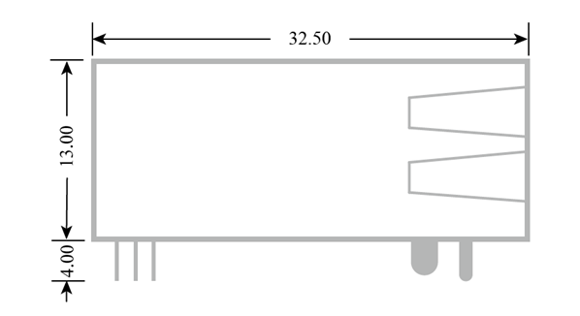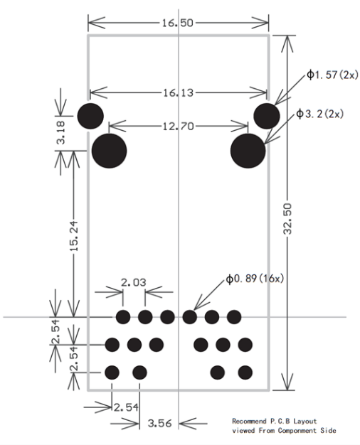
Figure 1-1 Mechanical dimension diagram of WIZ-IP20

Temperature characteristics
Table 1-3 Temperature characteristics
Name | level | Working temperature | Storage temperature
WIZ-IP20 | Industrial grade | -40℃ ~ +85℃ | -40℃ ~ +95℃

Hardware description

Interface description
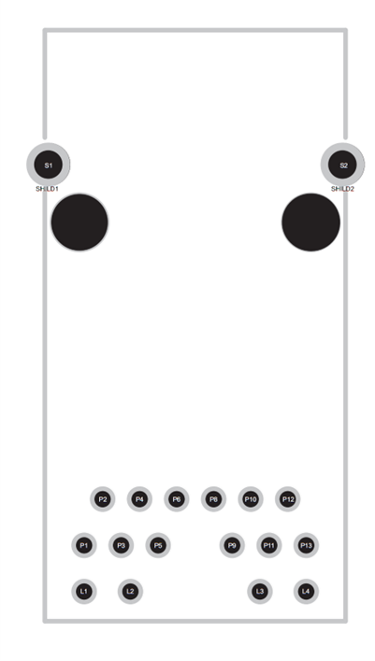
Figure 2-1 WIZ-IP20 pinout diagram

Table 2-1 WIZ-IP20 pin description
Pin Number | Pin Name | Pin Type | Description
P1 | ACT | RJ45_LED Control Pin | RJ45 Interface data status LED control
P2 | NC | - | -
P3 | RXD | Serial Port | 3.3V TTL serial port receive pin.
P4 | NC | - | -
P5 | TXD | Serial Port | 3.3V TTL serial port transmit pin.
P6 | NC | - | -
P8 | RESET | Reset Pin | The entire module is reset when a low - level signal is received.
P9 | GND | Power Ground | Module power ground
P10 | NC | - | -
P11 | VCC | Positive Power Supply Pin | Module power supply positive, default DC 3.3V
P12 | NC | - | -
P13 | LINK | RJ45_LED Control Pin | RJ45 Interface connection status LED control.
L1 | D1- | RJ45_LED | The negative pole of the RJ45 interface connection status LED is defaultly connected to the ACT pin
L2 | D1+ | RJ45_LED | The positive pole of the RJ45 interface connection status LED is defaultly connected to 3.3V power supply.
L3 | D2+ | RJ45_LED | The positive pole of the RJ45 interfacet data status LED is defaultly connected to the 3.3V power supply.
L4 | D2- | RJ45_LED | The negative pole of the Ethernet port data status LED is defaultly connected to the LINK pin.

Introduction to the Evaluation Board
The WIZ-EVB evaluation board enables users to test and evaluate the serial-to-Ethernet modules of the WIZ-IP32,WIZ-IP75 and WIZ-IP20 models.The interface diagram of the WIZ-EVB is shown in Figure 2-2.
Figure 2-2 WIZ- EVB Evaluation Board Schematic Diagram
- Power Switch:Used to control the power on/off of the entire circuit board, determining whether to supply power to the circuit board.
- USB-UART:USB to UART interface, providing 5V power supply to the circuit board and modules, enabling data conversion between USB and serial communication interfaces, used for AT command configuration and serial data transmission.
- USB-IP20:For firmware burning purposes.
- RESET:Reset button, when pressed, can make the circuit board or related functional modules restart and return to the initial state.
- Module Switch:When the button is pressed, it is configured to use the WIZ-IP20 mode; when released, it is configured to use the WIZ-IP75 or WIZ-IP32 mode.
- IP32-BOOT:Controls the startup mode of the hardware WIZ-IP32, used to force the module to enter the boot mode for firmware upgrade, debugging or fault recovery.
- IP75-BOOT:Controls the startup mode of the hardware WIZ-IP75, used to force the module to enter the boot mode for firmware upgrade, debugging or fault recovery.
- IP20-BOOT:Controls the startup mode of the hardware WIZ-IP20, used to force the module to enter the boot mode for firmware upgrade, debugging or fault recovery.

WIZ-IP20-EVB schematic diagram reference
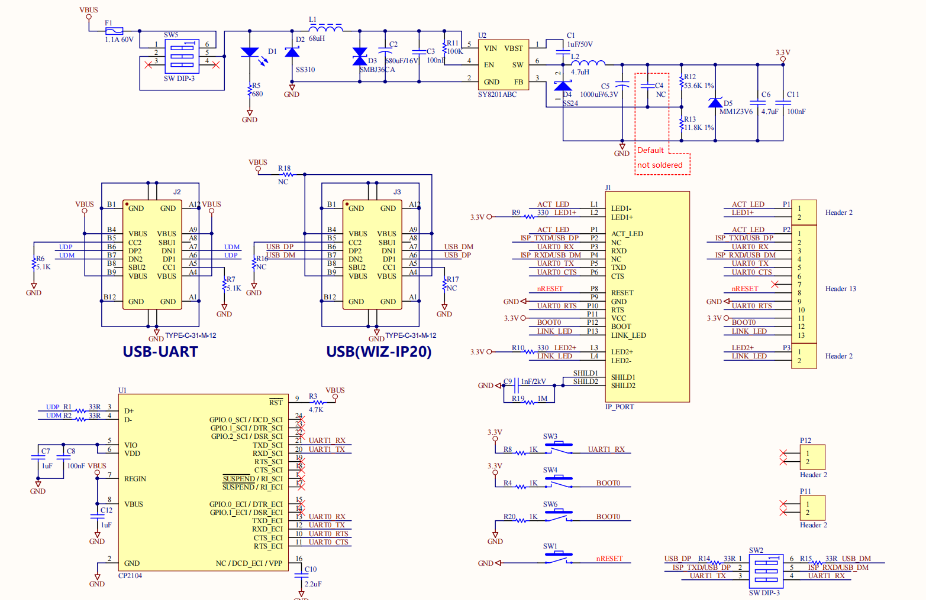Figure 2-3 WIZ-IP20-EVB schematic diagram

2.3 Quick evaluation wiring instructions
By integrating the WIZ-IP20 serial to Ethernet module, users can quickly upgrade the serial port of their modules to an Ethernet interface. Before doing so, it is recommended that users test and evaluate the WIZ-IP20 serial - to - Ethernet module through the WIZ-IP20-EVB evaluation board.
As shown in the figure below, to test the data conversion from the serial port to Ethernet, it is necessary to install the WIZ-IP20 on the WIZ-IP20-EVB first. Then, connect the serial port of the WIZ-IP20-EVB to the USB port of the computer via a USB to serial module, and connect the network port of the WIZ-IP20-EVB to network modules such as routers or switches. At the same time, the user's computer should also be connected to this local area network. In this way, a simple network environment between the computer and the serial port module is set up. Then, as described in the subsequent chapters, the user's serial port module can realize data communication with the computer through Ethernet, and the WIZ-IP20 acts as a bridge for conversion between the serial port protocol and the Ethernet protocol.
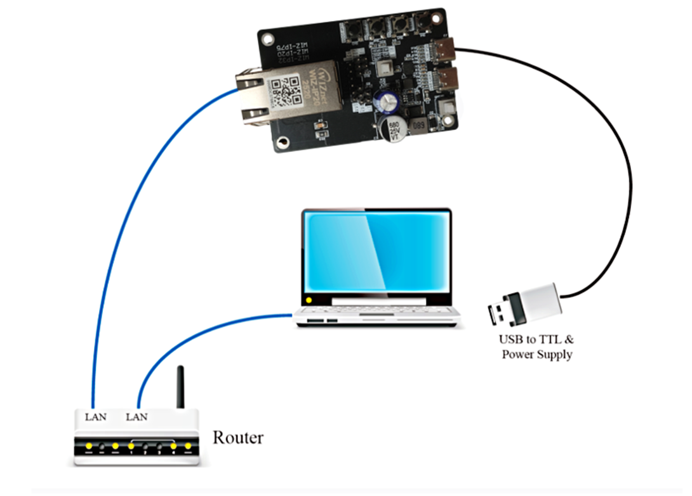
Figure 2-4 WIZ-IP20 wiring diagram

Operating modes
WIZ-IP20 serial to Ethernet modules support TCP Server, TCP Client, UDP, and Modbus working modes, which will be briefly explained below.

TCP server mode
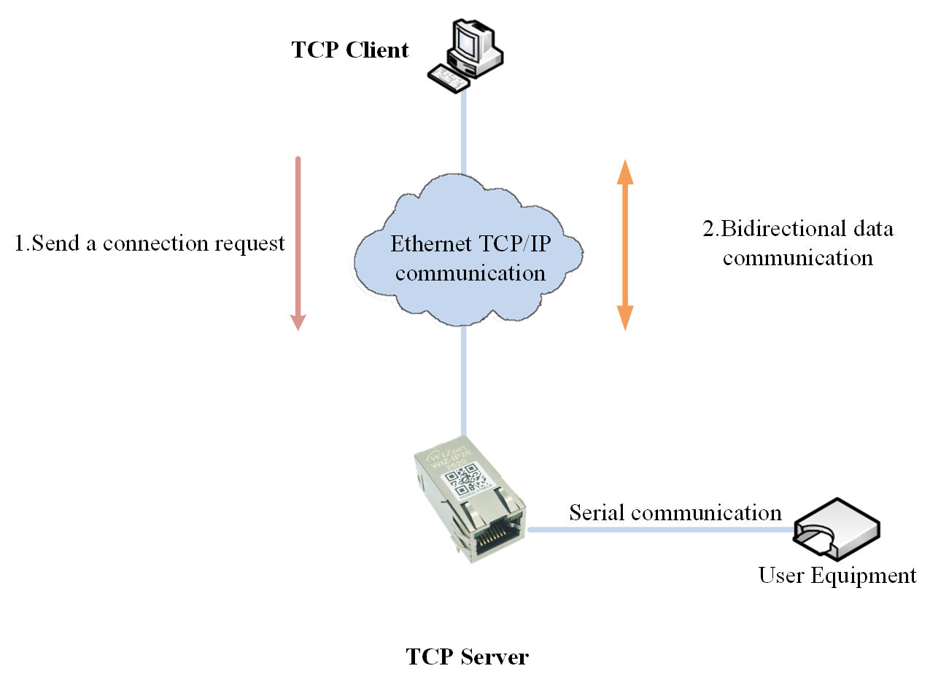
Figure 3-1 Schematic diagram of TCP server mode
As shown in Figure 3-1, in TCP Server mode, the WIZ-IP20 opens a local port for listening, with the default port number being 5000, waiting for connections from clients. Once a TCP connection is established with a client, bidirectional data communication can be carried out.

TCP client mode
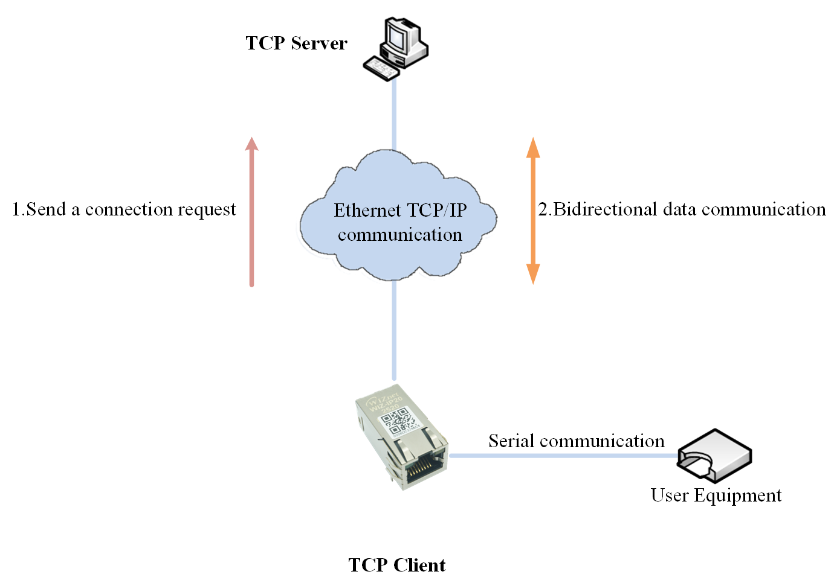
Figure 3-1 Schematic diagram of TCP client mode
As shown in Figure 3-2, in TCP Client mode, WIZ-IP20 will actively initiate connection requests to pre-set TCP servers. After establishing a TCP connection, bidirectional data communication can be carried out.

UDP mode
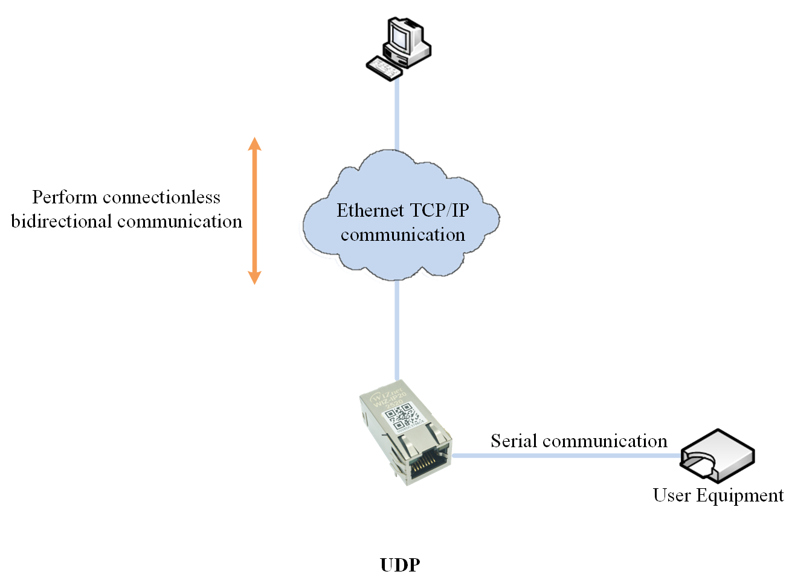
Figure 3-2 UDP mode diagram
As shown in Figure 3-3, the UDP mode does not require connection establishment. UDP communication can be realized by setting the IP addresses and port numbers of the WIZ-IP20 and the remote module.

Modbus mode
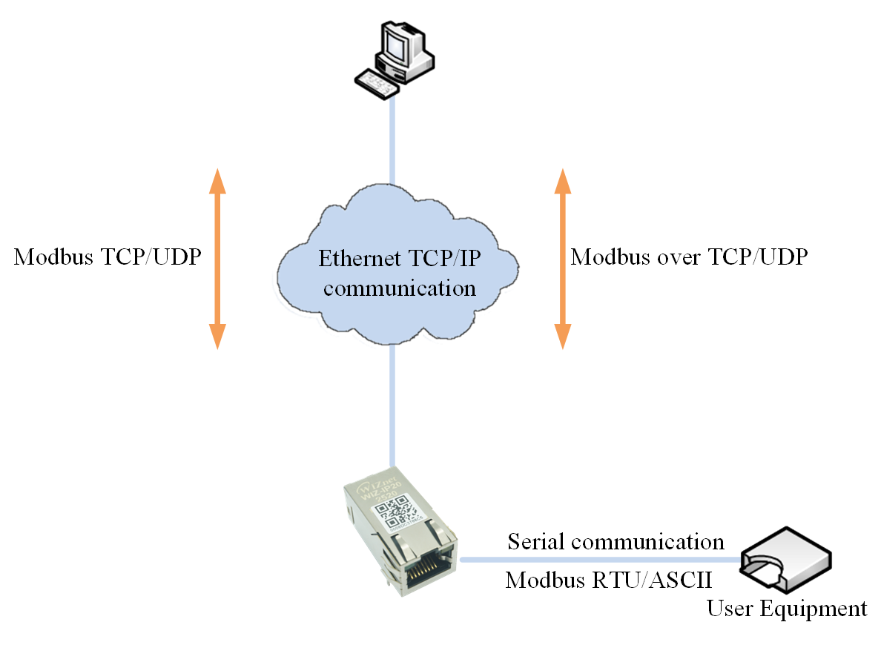
Figure 3-3 Modbus mode diagram
As shown in Figure 3-4, in Modbus mode, the WIZ-IP20 can realize the mutual conversion between Modbus RTU/ASCII protocols and Modbus TCP/UDP protocols. Meanwhile, the WIZ-IP20 also supports Modbus over TCP/UDP transmission.
Note: The Modbus function of the WIZ-IP20 is only valid in the data transparent transmission mode, and the Modbus function is not supported when transmitting data via AT commands.

Data transfer mode
WIZ-IP20 serial to Ethernet modules support two data transmission modes for users to choose from: data transparent transmission mode and AT command transmission data mode.

Data transparent transmission mode
The data transmission mode of WIZ-IP20 has the following characteristics:
- When using MCU to configure WIZ-IP20 for data transmission and receive, in general, before entering data transmission mode, it is necessary to configure parameters in AT command mode and then switch to data transmission mode;
- After entering data transmission mode, the module will operate according to the configured working mode:
  - When the module is in TCP Server mode, it will immediately establish listening until a client establishes a connection with it;
  - When the module is in TCP Client mode, it will immediately request a connection from the server until a successful connection is established;
  - When the module is in UDP mode, there is no need to establish a connection and wait for user data;
- After establishing a TCP or UDP connection, there is no need for any AT command operation, and the module can automatically send and receive data at any time, achieving transparent transmission of data;
- If the TCP connection is disconnected normally, the module will perform the following actions:
  - When the module is in TCP Server mode, it will re-establish listening;
  - When the module is in TCP Client mode, it will reapply for a connection to the server;
- When configuring WIZ-IP20 to send and receive data using MCU, if you need to modify the configured parameters, you need to exit the data transmission mode and enter the AT command mode for parameter configuration.

AT data transfer command mode
The AT command transmission data mode of WIZ-IP20 has the following characteristics:
- Configure in AT command mode and perform data transmission in AT command mode without switching operating modes;
- After configuring parameters in AT command mode, relevant AT data transmission commands can be directly called for TCP or UDP communication;
  - When configuring the module to TCP Server mode, the module will immediately establish listening until a client establishes a connection with it;
  - When configuring the module to TCP Client mode, the module will immediately apply to the server for a connection. If the connection cannot be successfully established within 3 seconds, a new command needs to be sent to apply for a connection;
  - When configuring the module in UDP mode, the module does not need to establish a connection and waits for user data;
- After establishing a TCP connection or UDP, sending or receiving data requires corresponding AT commands for operation, and only one data packet can be sent/received at a time;
- If a TCP connection disconnection is detected, the relevant AT data transmission command needs to be called again to establish the connection;
- If you need to modify the configuration parameters, you can directly call the AT command for configuration.

How to enter “Data pass-through mode”
Users can enter data transmission mode through three ways:
- AT command (see Chapter 7 "RESET" and "EXIT" commands for details);
- Web pages (see "Start Mode" option in Chapter 8 "Basic Settings" tab for details);
- WIZS2E Config Tool configuration tool (see "Enter... Mode when power on or reset" option in Chapter 6 "Additional Functions" for details).

WIZ-IP20's IP address
Before using WIZ-IP20, we need to know its IP address and other parameters. WIZ-IP20 supports two IP acquisition methods: "static configuration" and "dynamic acquisition". Static configuration "refers to the need for users to manually configure parameters such as IP address, subnet mask, and gateway. It should be emphasized that the module IP address cannot be the same as the IP address of other modules in the same local area network, otherwise communication cannot be achieved; Dynamic acquisition "refers to the module using the DHCP protocol to automatically obtain information such as IP address, subnet mask, and gateway from the DHCP server.

Factory setting of module IP address
The default IP address for WIZ-IP20 serial to Ethernet modules at the factory is 192.168.1.88.

Obtain module IP information
WIZ-IP20 has two methods to obtain module IP addresses:
- WIZS2E Config Tool upper computer software, refer to the instructions in Chapter 6.1 for details;
- AT command query, please refer to Chapter 7 "IP" query command for details

Method for determining if modules and computers are on the same network segment
Before using a computer to communicate with WIZ-IP20, users need to ensure that their computer is on the same network segment as WIZ-IP20. WIZ-IP20 is set with a default IP address (192.168.1.88) and network mask (255.255.255.0) at the factory. Users can check whether the module is on the same subnet as their computer according to the process shown in the following figure.
If in the same subnet, WIZ-IP20 modules can be directly used for communication. If they are not on the same subnet, it is necessary to set the IP address of the computer.
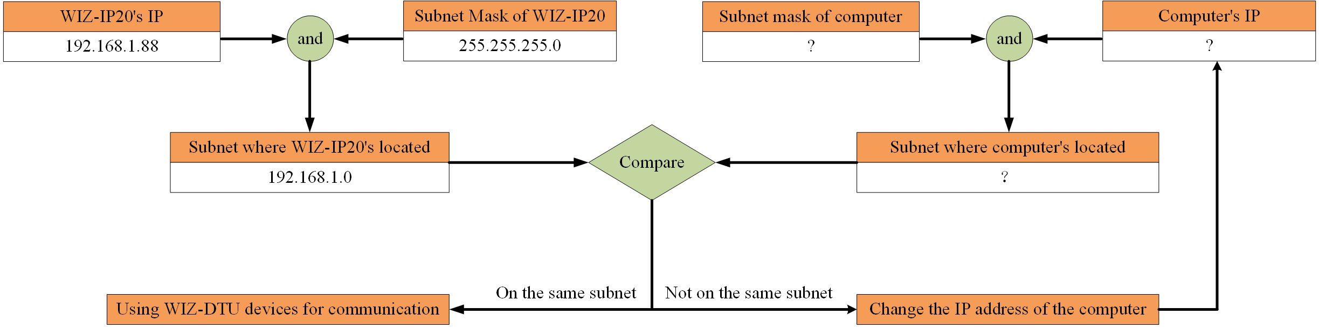
Figure 5-1 WIZ-IP20 and computer IP address same subnet detection

Computer IP setting method
Taking the Windows 10 operating system as an example for explanation.
Start → Control Panel → Network Sharing Center → Change Adapter Settings → Local Area Connection → Right click Properties → Double click Internet Protocol Version 4 (TCP/IPv4) to obtain the page shown in the following figure. Select 'Use the following IP address' and fill in the IP address, such as 192.168.1.99, subnet mask 255.255.255.0, default gateway 192.168.1.1, DNS section can be left blank, click' OK 'to complete the configuration. You can now communicate with WIZ-IP20 modules.
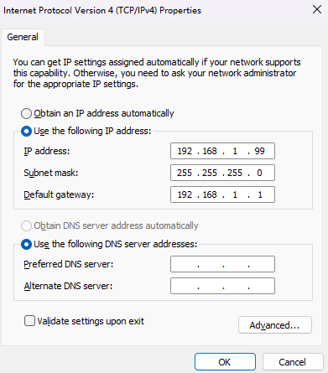
Figure 5-2 Windows 10 IP address setting interface

WIZS2E Config Tool software configuration
WIZS2E Config Tool is a upper computer configuration software that runs on the Windows operating system and is compatible with WIZ-IP20 and W5500S2E series serial port to Ethernet modules. Users can easily search, view, and configure various functions and information of the WIZ-IP20 serial port to Ethernet module through WIZS2E ConfigTool.
Note: It is recommended to turn off the firewall before configuration and ensure that the IP addresses of all modules in the local area network do not conflict.

Obtain module configuration information

Modify module configuration information

Reset module

Practical functions

Switch network card

Right mouse button

Factory reset
If users need to restore the WIZ-IP20 serial to Ethernet converter to its factory settings, there are three methods:software mode, AT command mode and web page.

Restore software to factory settings

Restore factory settings through AT command
Refer to Chapter 7 for details on the "DEFAULT" command.

Web page format
Please refer to Chapter 8.5 for an introduction to the module management interface.

Introduction of AT commands

AT command overview
The AT command supported by WIZ-IP20 serial to Ethernet modules is a standard interface that is not case sensitive and always starts with "AT" and ends with "\r\n". The format of its commands, return values, and parameters is fixed. Generally speaking, AT commands have the following formats:

AT command responds
According to the different AT commands input by the user, WIZ-IP20 will reply with the execution results of the commands, as shown in Table 7-1.

Entering AT command Mode.
There are two operating modes for WIZ-IP20 serial to Ethernet modules: AT command mode and data transmission mode. In AT command mode, users can use serial tools or configure various parameters of the module through their MCU, and also support data transmission under AT commands.
Note: If a TCP connection is established before entering AT command mode, the connection will be closed when entering AT command mode.
When WIZ-IP20 is in AT command mode, input the terminal detection command "AT\r\n" to its serial port. If the module correctly receives "AT\r\n", it will reply with "OK\r\n".
When WIZ-IP20 is in data transmission mode, any AT command input to the serial port is invalid. At this point, input "+++" to the serial port, and WIZ-IP20 will switch to AT command mode.
Input rule for "+++": Three "+" must be sent continuously to the serial port at once, and there must be no other characters within 1 second before and after the "+++" in order for WIZ-IP20 to respond correctly and switch to AT command mode.
Note: The default operating mode of WIZ-IP20 at the factory is AT command mode.

AT command list

AT settingcommand list

AT Data Transmission Command List

Detailed description of AT configuration command

Control command

module information configuration command

Serial port information configuration command

Management commands

Detailed description of AT data transmission command

AT command script examples

TCP server mode script example

TCP client AT command mode script example.

Web configuration

Login page

Basic settings

Channel configuration

Firmware information

Module management

Restore factory settings

Upper computer software mode

AT command mode

Web page format

Firmware upgrade

Firmware upgrade by WIZS2E ConfigTool

Firmware upgrade by web page

Appendix

Default list of occupied ports in Ethernet protocol

Product Repair Procedure
WIZnet HK promises to provide a one-year free warranty service for WIZ-IP20 equipment. Within one year from the date of purchase of WIZ-IP20 equipment, if there are any product quality problems during normal use, users can repair them through the following procedures:
- Provide proof of purchase.
- Obtain repair permit from WIZnet HK or distributor.
- Fill out the product problem report form and provide as much detailed information as possible about the reason for repair and the symptoms of the malfunction, in order to reduce repair time.
- Pack the equipment, send it to the designated repair address, and attach the product problem report form.
The following are not covered by the warranty. For damages caused to the product that are not covered by the warranty, we will only charge the cost of the components appropriately:
- Damage to the product caused by human or force majeure factors.
- Unable to provide proof of product purchase.
- products with a warranty period exceeding one year.

Product Problem Report Form
Corporate name
Contacts |  | Contact Number
Email |  | purchasing date
PRODUCT MODEL |  | serial number
notes
Problem description: (Please provide a detailed description of the problem that occurred and list all the error messages you have seen in detail)
__________________________________________________________________________________________________________________________________________________________________________________________________________________________________________________________________________________________________________________________________________________________________________________________________________________________________________________________________________________________________________________________________________________________________________________________________________________________________________________________________________________________________________________________________________________________________________________________________________________________________________________________________________________________________________________________________________________________________________________________________________________________________________________________________________________________________________________________________________________________________________________________________________________________________________________________________________________________________________________________________________________________________________________________________________________________________________________________________________________________________________________________________________________________________________________________________________________________________________________________________________________________________________________________________________________________________________________________________________________________________________________________________________________________________________________________________________________________________________________________

Disclaimers
This document provides information about WIZnet HK products. This document does not grant any intellectual property license, whether express or implied, or by prohibiting speech or other means. WIZnet HK shall not be liable for any other responsibilities except those stated in its product sales terms and conditions. Furthermore, WIZnet HK makes no express or implied warranties with respect to the sale or use of its products, including warranties of fitness for a particular purpose, merchantability, or liability for infringement of any patent, copyright, or other intellectual property rights. WIZnet HK products are not designed for medical, life-saving, or life sustaining purposes. WIZnet HK may make modifications to product specifications and descriptions at any time without prior notice.
WIZ-IP20 modules are high-tech products that may contain certain design defects or undiscovered errors. Once discovered, they will be included in the errata and may result in differences between the product and published specifications. If requested by the customer, the latest errata sheet can be provided.
Before ordering products, please purchase from WIZnet HK or designated distributor through the contact information provided on the "Sales and Service" page of this document and obtain the latest specifications.
For more relevant information, please visit the official website of WIZSE S2E at:https://wizse.com/

Declaration
Application Information
The cases or intentions in this application information are hypothetical and only intended to help users familiarize themselves with the product's features and usage methods. Customers must make modifications and validate based on the characteristics of their product before developing it.
The right to modify documents
WIZnet HK reserves the right to modify this document at any time without prior notice.

